ACO MUSIC & MOVEMENT CLASSES 2024

INFORMATION PACK (GREEN CLASS)
ACO Music & Movement classes are quality music learning experiences for 2.5 - 5 year olds – expertly led and based on well-founded music education principles.
Children will be introduced to musical concepts through singing, playing, and moving, and will develop their creativity and expression through improvisation and dramatisation activities. Led by a highly experienced early years music educator, classes will use a combination of Dalcroze, Kodaly and Orff teaching methods and activities, tailored specifically for the age and developmental stage of the children. Class sizes are kept intentionally small, and children will progress at their own pace.
Most importantly, ACO Music & Movement classes are fun and will ignite in children what will hopefully be a life-long love of music. Focus is on unconscious learning so that children are not inhibited by set musical ideas – allowing them to become creative musical thinkers before going on to more formal instrumental education.
CLASS DESCRIPTION
Class Type: Green Class
Age group: 2.5 - 3 Years
Class Time: Mondays, 9:30am – 10am
Teacher: Simona Green
This 30-min class for 2.5 - 3-year-olds will start children on their music learning journey. Children will be introduced to basic musical concepts and develop critical gross and fine motor skills through singing, rhythmic movement, simple percussion activities, action songs, finger play, and dramatisation games.
2024 TERM DATES
TERM 1 Monday 5th February – Monday 25th March
TERM 2 Monday 6th May – Monday 1st July
TERM 3 Monday 29th July – Monday 16th September
TERM 4 Monday 21st October – Monday 9th December
Term 1 |  | Term 2 |  | Term 3 |  | Term 4
Lesson 1 | 05/02/2024 | Lesson 1 | 06/05/2024 | Lesson 1 | 29/07/2024 | Lesson 1 | 21/10/2024
Lesson 2 | 12/02/2024 | Lesson 2 | 13/05/2024 | Lesson 2 | 05/08/2024 | Lesson 2 | 28/10/2024
Lesson 3 | 19/02/2024 | Lesson 3 | 20/05/2024 | Lesson 3 | 12/08/2024 | Lesson 3 | 04/11/2024
Lesson 4 | 26/02/2024 | Lesson 4 | 27/05/2024 | Lesson 4 | 19/08/2024 | Lesson 4 | 11/11/2024
Lesson 5 | 04/03/2024 | Lesson 5 | 03/06/2024 | Lesson 5 | 26/08/2024 | Lesson 5 | 18/11/2024
Lesson 6 | 11/03/2024 | NO CLASS | 10/06/2024 | Lesson 6 | 02/09/2024 | Lesson 6 | 25/11/2024
Lesson 7 | 18/03/2024 | Lesson 6 | 17/06/2024 | Lesson 7 | 09/09/2024 | Lesson 7 | 02/12/2024
Lesson 8 | 25/03/2024 | Lesson 7 | 24/06/2024 | Lesson 8 | 16/09/2024 | Lesson 8 | 09/12/2024
 |  | Lesson 8 | 01/07/2024

*Please note, that Monday 10th June 2024 is a public holiday and there will be no class that day.
WHAT TO EXPECT
When you arrive in The Studio, children will be asked to remove their shoes, but leave their socks on, and sit on the rug in the middle of the room. Parents and carers will be able to sit on chairs around the room, and siblings and prams are welcome in the space.
In the Green Class, parents are encouraged to sit on the floor and participate in activities with children - this may be necessary if your child is new to the class and still developing confidence to participate independently. Please note, at this age group a parent or carer must be always in the room with children.
Please bring a water bottle for children and note that eating, video and/or photography is not permitted during the class.
VENUE
ACO Studio, Pier 2/3, 13A Hickson Road, Dawes Point.
When you arrive at Pier 2/3, the ACO is located toward the furthest end of the Pier. You can walk down either side of the Pier, enter the doors into the building and into a large ground floor foyer. The ACO is located on Level 1. Go up the central staircase or in the bronze lifts and you will see the ACO ticket desk and reception area at the top of the stairs, in an area called the Level 1 Foyer.
The Studio is located down ‘the Crawford Corridor’. An ACO staff member will be there to help direct you from the foyer to The Studio for the class.
There are accessible bathrooms and baby change facilities available at Pier 2/3. If you are coming with a pram, all levels of the building are accessible by ramp and/or lift.
The Level 1 foyer space is open to the public and you are welcome to sit at the café tables before and after classes to enjoy the views. Please note that on a usual Monday, the Pier 2/3 foyer bar will not be open, so no food or beverages are available to purchase on site.
The closest café is Mr Jones (located in the Sydney Dance Company foyer on Wharf 4/5) - a very short walk to Pier 2/3. You are welcome to bring takeaway coffee or tea into The Studio at ACO.
HOW TO FIND US.
ARRIVING BY CAR / PARKING
There is ample street parking (2-hour and 4-hour) available on Hickson Road, Pottinger Street, Windmill Street, and Lower Fort Street. $8/hr peak, $6/hr off- peak (Ticket parking rates 2023-2024)
There are also several parking stations nearby which offer Early Bird and casual hourly rates before 5pm weekdays. Bond One Car Park (entry via 26 Hickson Road), Barangaroo Point Car Park (entry via Hickson Road), Barangaroo Reserve Car Park (entry via 5 Towns Place). All car parks are operated by Wilson Parking: www.wilsonparking.com.au.
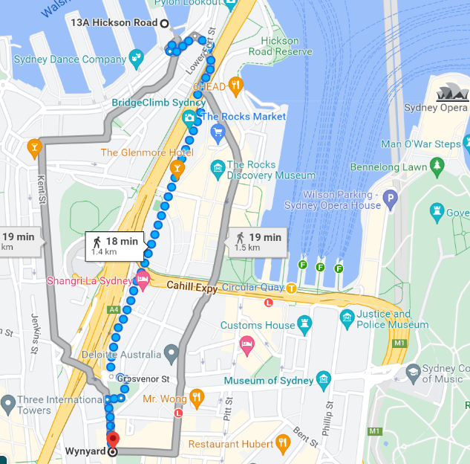
ARRIVING BY PUBLIC TRANSPORT
TRAIN
Wynyard Station is a 20-minute walk to Pier 2/3, and Circular Quay is a 15-minute walk.
Both stations service all major trainlines in the Sydney Rail network.
Wynyard is further but the route is more accessible and flatter, whereas Circular Quay involves many steps and steep inclines.
FERRY / LIGHT RAIL
All ferry services, light rail and some bus routes stop at Circular Quay.
The light rail passes through Central, Town Hall and Wynyard before coming to Circular Quay.
The ferry wharfs and light rail terminals are a 15-minute walk to Dawes Point.
Wynyard Station
to Pier 2/3

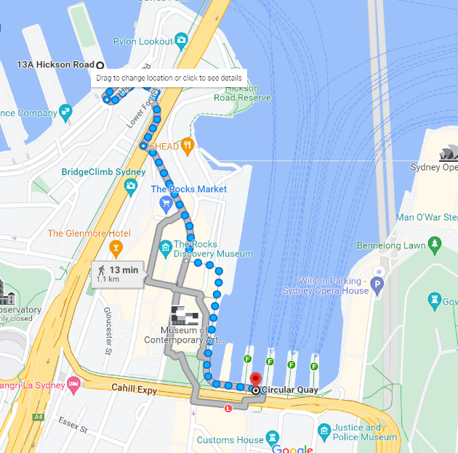
Circular Quay
to Pier 2/3

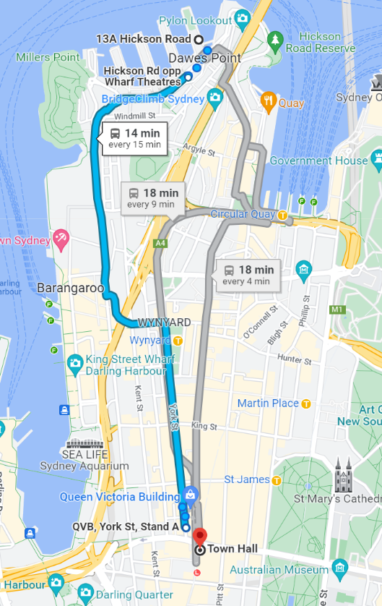
324 Bus Route
BUS
The 324 and 325 bus from Watsons Bay to Walsh Bay stops out the front of Pier 2/3 on Hickson Road.
There are several stops in the city at Wynyard and Town Hall where you can get on this bus.
Please see route from Town Hall to Walsh Bay marked in blue to the left.

Visit the ACO website for more information on visiting Pier 2/3: https://www.aco.com.au/pier23/your-visit

