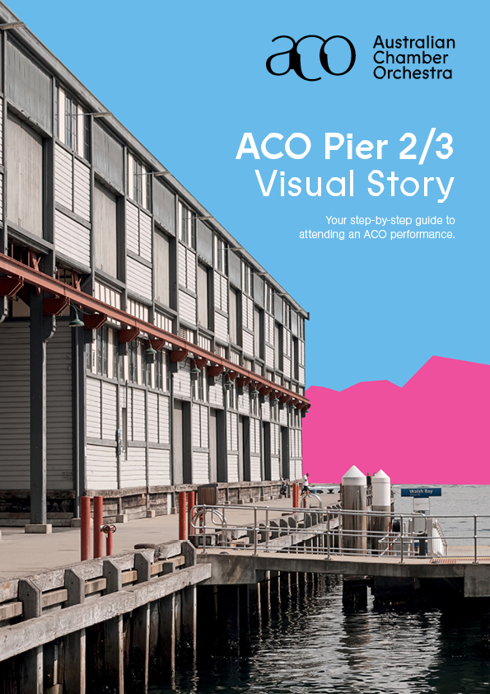
ACO FAMILIES: The Princess, The Pea (and The Brave Escapee) Relaxed
Schedule
To help you plan your visit, here are the performances timings.
10.30am The foyer will be open and there are free creative activities you can participate in. You can buy a drink or a snack at the bar if you would like to.
11.15am The theatre will open and you can find your seats.
11.30am The performance begins.
12.10pm The performance will finish.

The ACO staff are there to help with any questions. You can contact
us by phone on 1800 444 444 or email boxoffice.c@aco.com.au.

How to get to the ACO
The ACO is located at Pier 2/3, Suite 3, 13A Hickson Rd, Dawes Point.
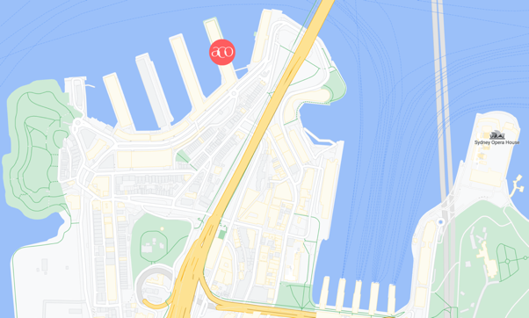
You can find out more about visiting ACO on the website’s
‘Plan your Visit’ page and the ‘Accessibility’ page.

Arriving at the ACO

The ACO is located at the far end of Pier 2/3. You can enter the Pier from either side.

A) The Western side of the Pier has a sign saying ‘Pier 2/3’

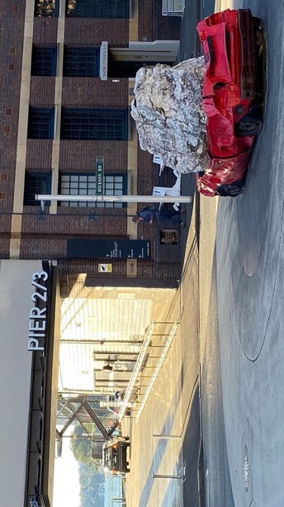
You can walk through this entrance and walk along the ground level, past Bell Shakespeare Company, until you see a sign saying the ‘Australian Chamber Orchestra’.
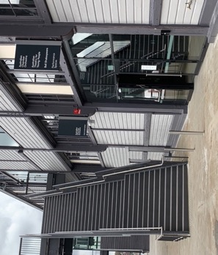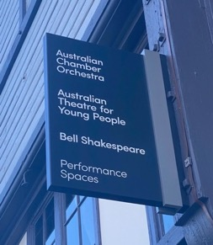

B) You can also enter from the Eastern side, where you will walk past the Australian Theatre for Young People and up the ramp or stairs.

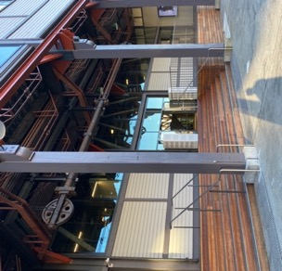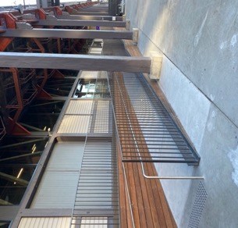

You can enter the building through the big glass doors on either side of the Pier and you will be in the ground floor foyer. You can then either take the stairs or the bronze lifts up to Level One where you will find the ACO Foyer.

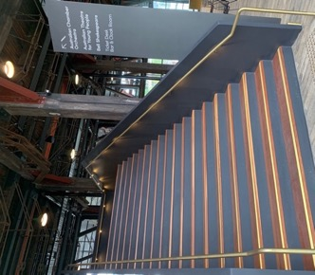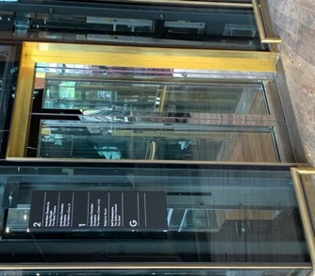

Inside Pier 2/3

Once you are on Level One, you can pick up your ticket from the Ticket Desk (or access the email ticket on your phone).

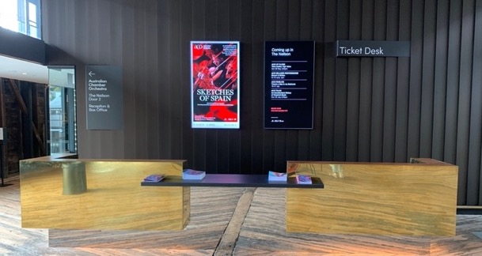

Before the performance, you can purchase drinks or snacks at the bar in the foyer.

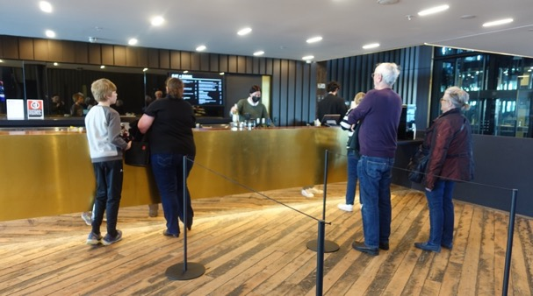

You can find Accessible Toilets on all levels of this building.

If you need assistance with finding your way or anything else, you can ask an ACO Usher for help. They will be wearing black t-shirts and an ACO badge.

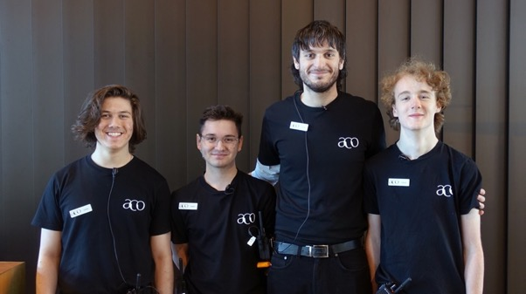

Entering the performance space

The performance will be in the ACO’s theatre called The Neilson.

You will enter The Neilson via Door 1 on the Eastern (right) side of the building, or Door 2 on the Western (left) side. An ACO Usher will show you the way.

Door 1
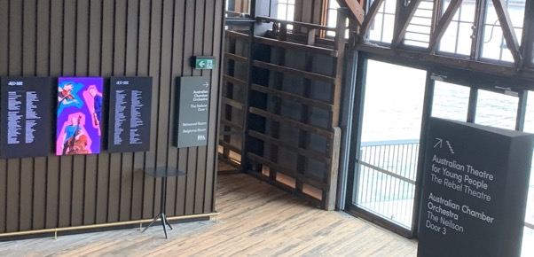

Door 2
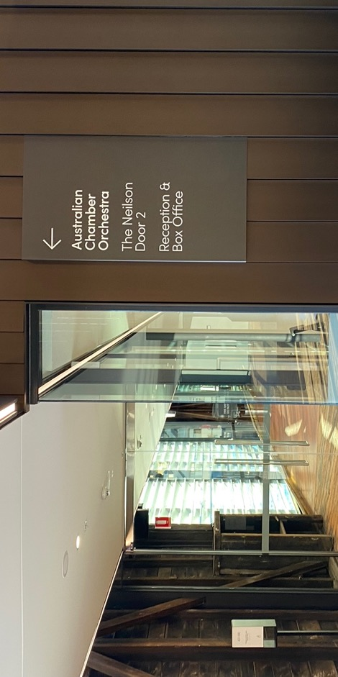

An ACO Usher will check your ticket as you enter The Neilson.

When you enter the performance space, you will be able to choose where you would like to sit. There will be fixed seats or the option to
sit on the floor.
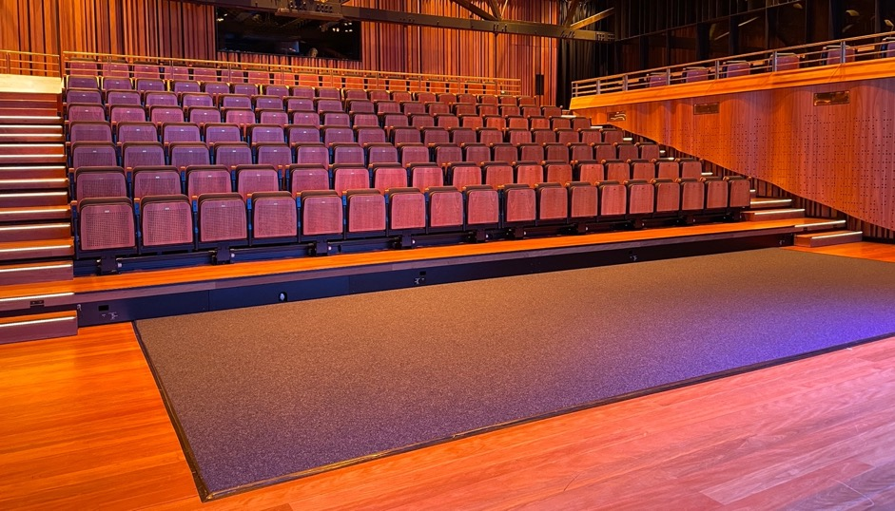
The Performance
In the theatre, there will be a stage set to look like an old fashioned stage, from back in time. The set is blue, with red curtains. On the stage you will see music stands and microphones, and there are large wooden chests placed in front of the stage. There is a circular piece of white fabric in the centre of the stage.

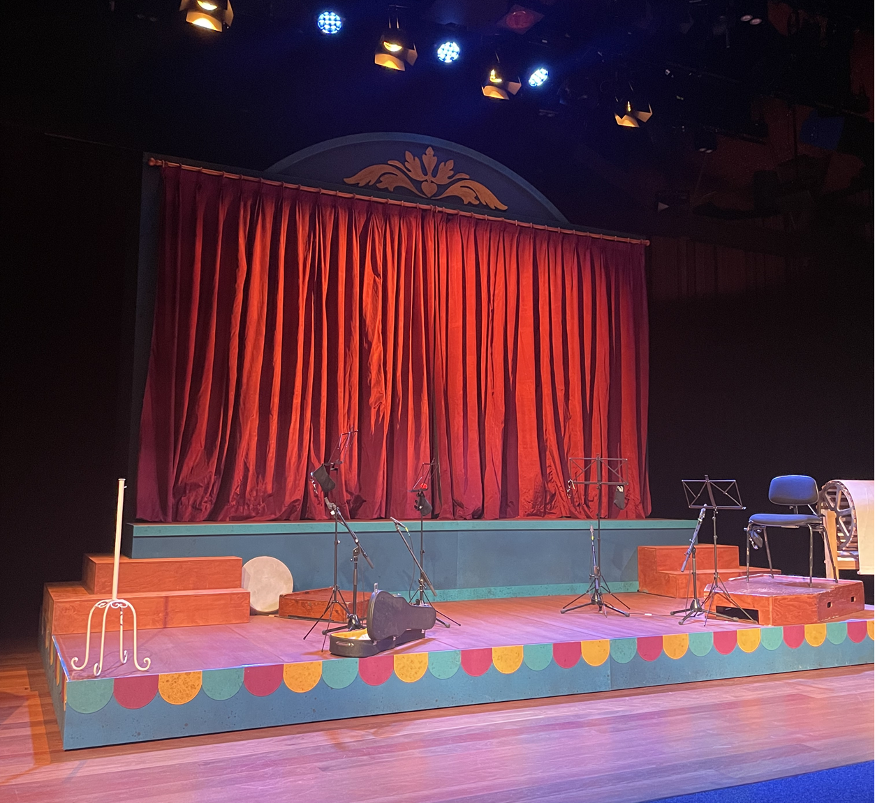

When the performance is about to start, the ushers will close the doors, the lights will dim. Four musicians and one actor will enter the stage. There will be a recorded announcement, and then the performance will commence.

The performance will last about 40 mins and after the show, the musicians will talk to the audience about their instruments.
The Quiet Space

If you need a break from the performance at any time, you can leave The Neilson and go to the ‘quiet space’. To leave the theatre you will need to go up the stairs and exit from the top door.
An usher will help you find your way out of the theatre and downstairs to the quiet space.

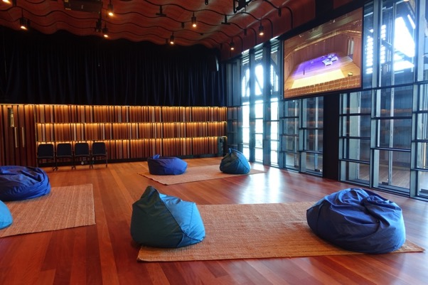

The Quiet Space will have chairs, rugs and cushions and a screen showing the performance.

